Lesson 6: Answer Key

Soccer Assessment Key

Scoring Guidance. The elements described below would be considered an exemplary response at this point in the unit. These are shown as purple text or in purple diagrams below the related question. In some cases different elements of the response are identified with a separate + symbol These +’s are not meant to be all inclusive; they are suggestions for what you may see your students include.

If several of the ideas marked with a + are missing from a student’s response, this may indicate the student has not mastered the science ideas or that the student may be struggling to bring those ideas together in a written explanation or model. Additional probing of their thinking can provide insight about whether the student is struggling with a science practice or science idea, or both. If all or almost all of the ideas marked with a + are present in a student’s response, this may indicate the student has mastered the science ideas and is able to use them in a written explanation or explanatory model.


Soccer is becoming more and more popular in the United States and while other injuries are happening less frequently, youth soccer players in the U.S. are experiencing more concussions. A concussion is a type of traumatic brain injury caused by the head moving quickly back and forth and the brain bouncing around in the skull.

A concussion can result from a force of 400–1000 N on the head. There has been debate in different sports about how to best prevent concussions. In soccer, one idea is to ban headers (when a ball makes contact with a head) in youth and professional soccer.

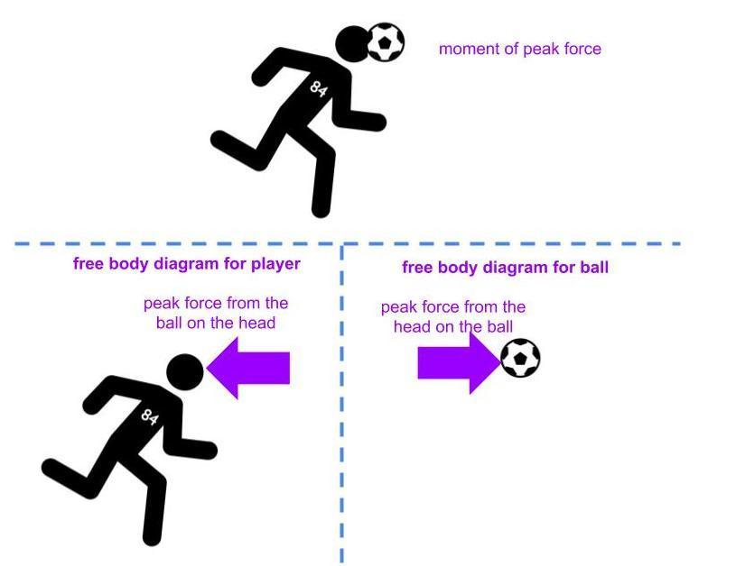
1. How would the forces from a header from such a light soccer ball cause a concussion? Draw two free-body diagrams showing how the amount of peak force on the head would compare to the amount of peak force on a soccer ball in a header that causes a collision.
An example of what a student free body diagram could look like is should here:

There are three types of collisions that tend to happen frequently in soccer: a) headers, b) collisions between players heads and c) when players' heads hit the ground.

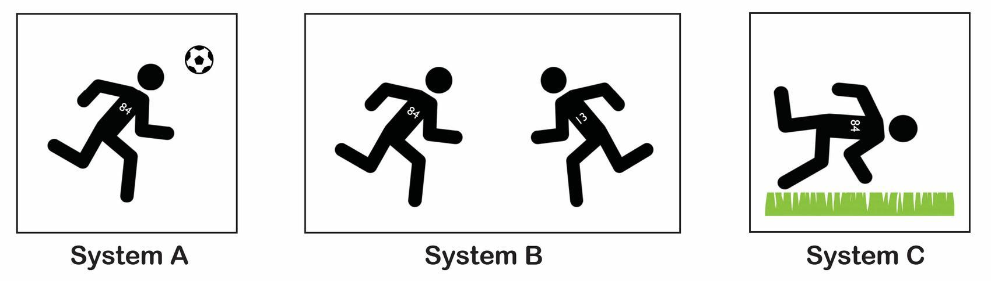

2a. How would the amount of force on the head compare to the amount of force on the object it collides with, in each system A, B, and C?
- In every collision, the peak force on the head would be the same as the peak force on the other object in the collision.
- In some, but not all collisions, the peak force on the head would be the same as the peak force on the other object in the collision.
- In every collision, the peak force on the head would be different than the peak force on the other object in the collision.

Correct response is a.

2b. Explain in words or pictures your choice in 2a.
Student responses should include these ideas:
+ You can’t have force on only one object when it makes contact with another object (forces come in pairs).
+ These contact forces are always equal, even if one object has more mass or more speed before they make contact in a collision.

Sports scientists concluded that concussions result from headers, a running player colliding with another running player and a running player hitting the ground. So far in this unit, we have looked at collisions and how much kinetic energy the objects in the system have before they collide and how this is related to the peak forces they can produce in any collision. Let’s consider the three main types of systems that can lead to concussions and make predictions about them using forces and energy as it relates to Player #84.

3a. Considering both objects that are about to collide in each interaction, which system would you predict to have the least amount of total kinetic energy in the system right before the objects collide? In each instance below, Player #84 is running at a speed of 7 miles per hour. Circle one.

A. Player #84 running and heading the soccer ball that was kicked by another player
B. Player #84 running and colliding with another running player running towards them
C. Player #84 running and hitting the ground

Expected response:
C

3b. Explain in words and pictures using the images below why this system would have the least kinetic energy before the collision by comparing it with the two other systems.

Student responses should include these ideas:
+ There are two objects in each system (A, B, and C) that will collide; the total KE is based on both.
+ In each system (A, B, and C) player #84 would have the same amount of KE because in each case it’s the same player with the same mass and speed.
+ The ground is not moving in system C, so it has no KE.
+ There is a second object moving in A and B (a ball or another person), meaning each of these also have KE.
+ So therefore, the total KE in system C should be lower than the other two systems.

4. Based on your answer above, which system should have the least amount of peak forces during the collision? Why?
Student responses should include these ideas:
+ Total peak force is related to the amount of total KE in the system.
+ So the system with the least KE (system C) should result in the least amount of peak force during the collision.

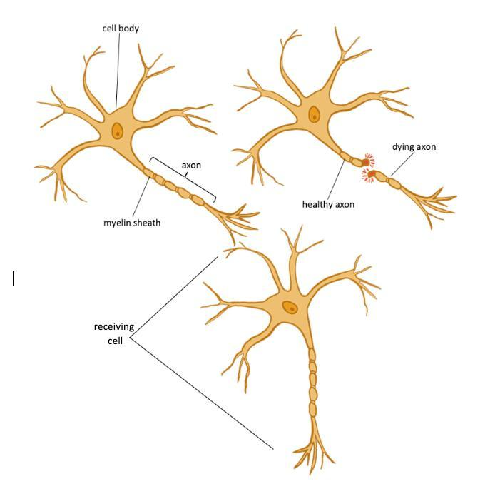
5. The brain is an organ made of interconnected cells called neurons. Neurons send signals to communicate information from one cell to another. The long part of the neuron is called an axon, and they have a breaking point. Recent research provides evidence that permanent damage to axons in the brain occurs from just a single damaging head collision (concussion).

Write an argument: During a head collision, which system (A, B, or C) would be most likely to cause damage to some of the axons in the brain? Use ideas related to kinetic energy, peak forces, and breaking point for the structures in the brain, axons, in your argument.

Student argument should be either of the following:
+ The collision in system A is more likely to cause damage to the brain because a soccer ball can move really fast, and speed is related to KE … OR
+ The collision in system B is more likely to cause damage to the brain because another person running is big and has a lot of mass, and mass is related to KE.

Student chain of reasoning should include the following:
+ Mass is more important than speed for total KE or vice versa (we don’t have strong evidence for resolving which is more important yet, so either response is justifiable for this prompt).
+ The peak force is related to the amount of total KE in the system before the collision.
+ So the system with more KE should result in a higher peak force during the collision.
+ The axons will only break if the peak force exceeds their breaking point.
+ This is why system A (or system B) is more likely to cause damage to some cells in the brain in a collision.

6. Do you think the mass of a moving object or its speed is a bigger factor contributing its kinetic energy and the resulting damage that it can do in a collision? Why? Use any experiences you’ve had as evidence in your argument as well as any science ideas you think are relevant.

Look for justification from real-life experiences.
Capitalize on the differences of ideas and circumstances--some students will say mass, others will say speed (a speeding bullet vs. an elephant running).
Students may or may not add ideas about KE or energy transfer.
Utilize this difference to navigate into Lesson 7 at the end of Lesson 6. Guidance is provided in the Teacher Guide for this.

7. Suggest one or more ways we could use the materials from previous investigations to determine whether doubling the mass of a moving object or doubling its speed has a bigger effect on the amount of damage it does in a collision.

Look for any ideas that students suggest. These ideas prime students thinking for the work they will do in the next lesson where they will collect data from an investigation around this question.

